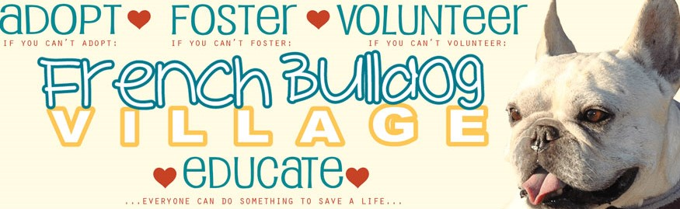SAMPLE FBV ADOPTION APPLICATION
**FBV Adoption Application Fee
Please note…a $10 non-refundable application fee is required. Your application will not be processed without the fee. This fee helps to offset a small portion of our rescue’s expenses.

CONTACT INFORMATION
Name:
Address:
Home Phone:
Cell Phone:
Email:
ABOUT YOU AND YOUR HOUSEHOLD
Age of applicant:
Occupation of applicant:
If you have a partner, what is the person’s occupation?
MEMBERS OF YOUR HOUSEHOLD (Please list the names of ALL members of your household, along with their ages and relationship to you.)
Name: Age: Relationship:
Name: Age: Relationship:
Does anyone in your household suffer from allergies?
PLEASE LIST ALL PETS IN YOUR HOUSEHOLD (List the name, type of pet, breed, gender, age, and whether or not the pet is altered.)
Pet Name:
Type of Pet:
Breed:
Gender:
Age:
Altered: Yes or No
BREED and DOG KNOWLEDGE
Tell us what you know about the health problems of brachycephalic (short-nosed) dogs:
Tell us what you know about the French Bulldog breed:
Please detail your experience working with dogs in general:
Please detail any experience you have in working with rescue dogs:
ENVIRONMENT
Please check the type of housing you live in: House, Condo, Apartment, Trailer
Do you rent or own?
If you rent, will you be able to provide your landlord’s written permission to have pets?
Do you have a yard?
If you have a yard, is your yard fenced?
What type of fence do you have? Privacy, Chain link, Other
Do you have a pool?
If you have a pool, is it fenced in?
Do you have air conditioning? Yes- window air conditioners, Yes- central air conditioning, No- I do not have air conditioning
Who will have primary responsibility for the dog?
Is someone home during the day?
How many hours will the dog be alone each day?
Where will the dog sleep at night?
If you travel, where will the dog stay: Boarding/kennel, At a friend/relative’s house, Someone will stay at our home
Please detail how you will meet the special needs of this particular dog?
REFERENCES (Please provide the contact information for your references.)
Veterinary Reference:
Phone:
Address:
Breeder, Rescue or Animal-Related Volunteer Reference (if you do not have one, please provide a personal reference not related by blood or marriage):
Phone:
Address:
ADDITIONAL INFORMATION
Are you a member of any dog clubs, SPCA, Humane Society, etc.? Please list them here:
Is there any other information that you feel would help us more fairly evaluate your application?
Transportation is the responsibility of the new owner. How do you intend to pick up your dog?
Are you at least 21 years old or older?

I have answered all the questions contained in the French Bulldog Village Adoption Application truthfully, to the best of my knowledge and ability. I understand that, if for any reason, I can no longer care for or keep a dog that I have acquired through the services of the French Bulldog Village, I must return it directly to lister from whom I acquired the dog, and I will sign all necessary papers for the surrender of the dog. By submitting this form, I hereby make application to the French Bulldog Village to be considered for the purpose of adopting a French Bulldog. ⃝ I agree

After the form is submitted, you will be redirected to the PayPal website. Your application will not be processed without the $10, non-refundable, adoption fee. After you hit submit, you will no longer be able to return to your previously saved application.

